Y2K REDUX -- INVESTORS PILING INTO ALL THINGS "DOLLAR". . .AND THEN SOME!
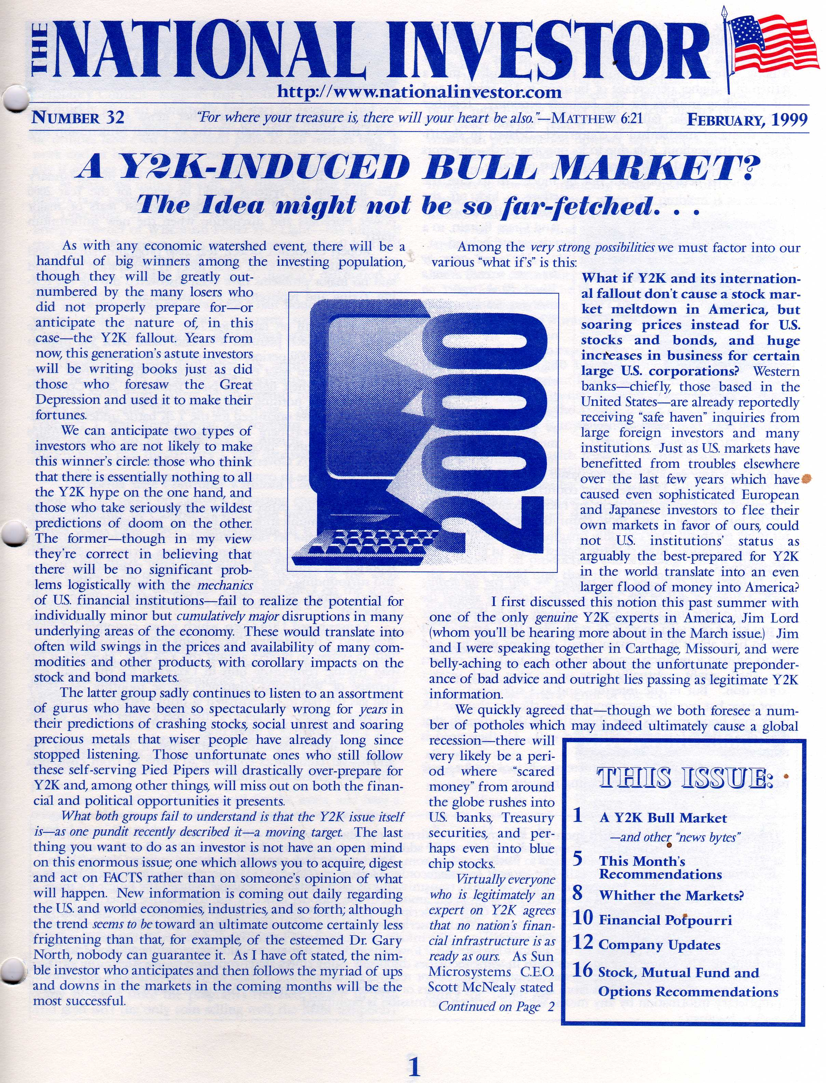
Some market fundamentalists I follow -- and especially some of the usual suspects among "perma bears" -- were apoplectic at week's end. As I mentioned at the close of the day in Friday's market wrap (at http://www.kereport.com/2016/07/08/dow-jones-industrial-average-standard-poors-nasdaq-closed-today-unemployment-rate-49/) the Standard & Poor's 500 index most notably came within a whisker of closing at a new all-time high. More incredibly, rather than being lower at the end of the day as stocks surged higher, "The Odd Couple" as I have come to describe them--Treasuries and gold--powered higher in price at the same time! What gives?
I'll have more extensive comments further along in this (yes, again!) expanded issue. To open up with I want to reiterate what I said on Friday's market close: the present environment is much like that during the Y2K craze that saw a stampede into U.S. dollar-denominated assets of virtually all kinds, as well as into gold.
To be sure, there are a few key differences; they may or may not have to be reckoned with before long. But by and large, the outcome in the markets is the same: investors the world over see U.S. markets--together with precious metals and a couple other "safe havens"--as the best places for their money in a treacherous world.
When I wrote the above-featured February, 1999 issue of The National Investor, quite a few of my colleagues thought I was goofy. The fashionable thing in many circles, as you likely remember, was to see who could outdo their "competitors" in issuing the most dire predictions of a virtual financial Armageddon that was going to come at the stroke of midnight on January 1, 2000. Airplanes would fall from the sky. Gasoline pumps would not work. Ditto for ATM machines. Food couldn't be shipped. Brokerage accounts and retirement funds would virtually disappear, etc.
A lot of people made obscene amounts of money from and during the Y2K craze; usually, though, as they advocated DISASTROUS moves to the people they frightened into believing the Doomsday scenario. I can't tell you how many people I met who did things such as cashing in their IRA's (paying income tax AND the early withdrawal 10% penalty tax to boot) and putting what was left into so-called "rare" coins carrying mark-ups of 100% or more over the dealer's cost (sold to the gullible people because these types of coins are allegedly "non-confiscatable")
In the case of Yours truly, I didn't completely dismiss that there were Y2K issues with computerized systems, etc. I chose, though (among other things) to find opportunities for my Members to capitalize on those companies with solutions; and there were quite a few. Goosed to a great extent by considerable exposures to these Y2K software and similar companies (and one Y2K-specific mutual fund) our OVERALL portfolio was up triple digits in 1999.
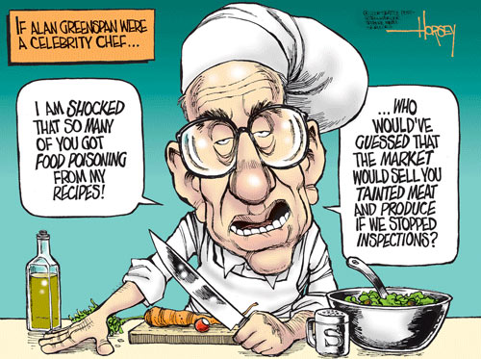
More broadly, though (and getting to the lesson this has for us today) there was one BIG underlying reason why I was convinced that U.S. markets were going to have a stellar 1999: then-Fed Chairman Alan Greenspan.
You've often heard me insist that--in the long history of the United States of America--there has NEVER been a single more destructive policy maker than Greenspan. A man who was alleged previously to have been an advocate of sound money and gold, Greenspan while chairman of the Federal Reserve turned into a veritable monetary mad scientist. Among other things, he was chiefly responsible for helping push for the dismantling of the old Glass-Steagall Act; and in conjunction with the same mentality that drove this, he unleashed unregulated derivatives onto the markets. . .and the world.
I vividly remember the few times when Greenspan was ordered to come before Congress and explain what these derivatives even were and further why they should not be accounted for or regulated. As always, "The Maestro"--a central banker on whom was subsequently conferred a knighthood for God only knows what--was his usual half-confusing (but always condescending) self to the mere mortals on Capitol Hill. In short he gently scolded Members of Congress and the Senate alike that only he, the Great and Powerful Oz as it were, was meant to understand the intricacies of modern money mechanics. Who were they to quibble with the monetary sage of all time? We all know the destructive result of Greenspan's "work" now; at least some of it (only the first wave, I would contend, was felt big-time in 2008; more consequences will come eventually.)
Despite the above--and even-handedly giving credit where it is due--Greenspan did do one thing right during his otherwise ruinous tenure. And that is, he made absolutely sure that to the extent Y2K issues did need to be reckoned with, they would in the end NOT be an issue with U.S. markets and America's banking system. More important, the whole world knew this; and the stampede into U.S. financial assets from foreign investors added to the momentum that already existed, especially in the largest-cap tech shares, the dot-coms and the like.
The dynamic today is much the same. Earlier this year, it was more the fears over China and a debt implosion in the energy patch that had dollar-denominated assets and other safe havens such as gold and the Japanese yen enjoying disproportionately higher (or less bad) demand. Most recently, of course, it is the justifiable concerns over Europe's banks and the future of the European Union itself, with the recent "Brexit" vote (MUCH more on this further along as well) making all this worse. As we saw in incredible fashion at week's end, when you see precious metals, Treasury bonds (long-term ones hit yet new all-time price highs/low yields on Friday) and stocks all surging higher in tandem, it's attention-getting to say the least!
That the underlying fundamentals of even the "less bad" U.S. economy, and most notably the ongoing earnings recession, may not justify the market just about at its past nominal all-time high means relatively little when there are such powerful forces/reasons pushing capital into stocks. As CNBC's Rick Santelli quipped on this subject late Friday, "If you are looking at the fundamentals, it's great water cooler talk. But if you want to make money, the crowd's going to be right for a while." And in a warning to the perma-bears particularly he said, "There's no place to hide from a bit of bullishness in U.S. markets for a while."
On the surface, it surely looks as if pretty much all the rallies we've seen extended this past week may well continue indefinitely (though not all of them with the same "oomph" as I'll be discussing.) Yet we can ill afford to get too smug and think we're going to ride these rallies (especially speaking of stocks in general terms) THAT easily. For there are some noteworthy differences in the overall "recipe" of factors we must consider today compared to the far simpler environment of 1998 and especially 1999 that DID allow for one to be more aggressively bullish:
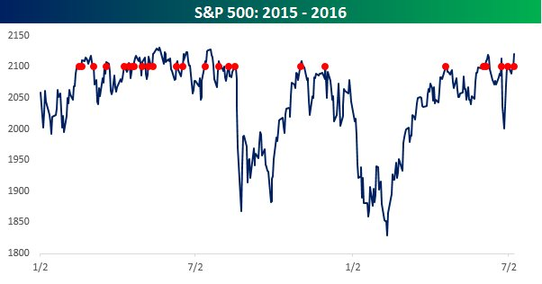
* Both the economy and the general stock market are far less healthy today -- The economic boom that peaked after we successfully got over that Year 2000 threshold was prior to that point fairly powerful. And though it eventually did get completely out of hand, the flood of foreign investment in our markets for safekeeping until Y2K was proven a non-issue augmented a strong bull market that was already healthy.
But here in 2016, neither stocks nor the economy are healthy in their own right, even if they are less bad than most others. And although the S & P 500 closed on Friday less than a point below its all-time closing high from early last year (that marker is 2130.82 if you're keeping score) it's noteworthy so far that the story has been that all these Y2K-like forces, rather than pushing a bull market in the U.S. ever higher, have instead succeeded only in keeping corrections at bay. As the above chart depicts, the S&P has been either side of 2100 countless times now over the last year and a half or so.
Even if we do soon see new closing highs for the U.S. stock indices, it may not be much; and as I'll detail later on, we still need to stay focused on those asset classes and stock sectors that are going to do well regardless. A lot of skepticism remains, together with reluctance on the part of U.S. retail investors to rejoin the party in any significant way.
* One good thing is that today's Fed is unlikely to repeat Greenspan's mistake of early 2000. -- All else being equal, the Janet Yellen-led Fed has already pretty much run up the white flag on any more rate hikes (near term, at least.) Back in 2000, Greenspan overdid things for a while in trying to take back some of the monetary stimulus and extra dough he put out pre-Y2K and thus exacerbated the dot-come crash, which then spread more to the broader market and the economy.
* Timing when this "perfect storm" supporting U.S. stocks (primarily) will end is not the sure thing it was in January, 2000. -- Just as I could look at things dispassionately in early 1999 and make the case that the year would see substantial gains for stocks, etc., it didn't take a genius to know that once the beginning of 2000 had come and gone without incident, it was time to cash in your chips. We did so where the dot-coms and stock market generally were concerned; but at the same time we started getting into the cheapest sectors (rate sensitive stocks, gold miners and others) that started to turn higher even as the major averages kept going down well into 2002.
Today, as we have already done, we can similarly do the latter of those things. Whether stock indices make new highs or not is somewhat immaterial. We will stay fixated on those areas that have already done very well for us, and will be adding positions.

Where stocks generally are concerned, though, we DON'T have any such date certain as was Jan. 1, 2000 at which we know the ingredients supporting recent moves will change. That will keep us on our toes!
* Leverage, contagion risk and the like are FAR worse today. -- Thanks for Greenspan having unleashed derivatives, securitization and all his other financial alchemy on the world we have markets today--including the "less bad" U.S. ones--that are FAR more at risk to sudden, unannounced convulsions. Yes, there is considerable liquidity still in the world. But that even goes just so far. When we can hear news as we did this last week of billions of pounds' worth of investors' assets in U.K. property funds frozen. . .Italy's banks crumbling. . .and even more palpitations elsewhere DESPITE the massive monetary stimulus that was supposed to prevent these things, you know the jig might be about up. I guess for our sake here in the U.S. it might be up for others sooner.
As we see the established order in many places (Europe mostly) continue to unravel, it is very likely that all of these factors supporting outsized flows of funds into U.S. financial assets will continue. But unfortunately, we probably won't know until after the dominoes have already started falling that messes elsewhere WILL be affecting us acutely, too.
So as always, I'll be doing my best to keep you comfortably IN most of those areas that we can do well in now, while always looking over my shoulder for ANY sign that all these momentum moves are under threat.
Now, before I get into a number of individual ETF and company updates--and some of them decidedly EXCITING ones at that!--I want to talk about some other market, asset class and post-Brexit/geopolitical items. . .
______________________________________________________________________________________________________________

The above excerpt is from the most recent regular issue.
For the full issue and all our content and recommendations you must be a paid Member; go to http://nationalinvestor.com/subscribe-renew/

______________________________________________________________________________________________________________
The National Investor is published and is e-mailed to subscribers from chris@nationalinvestor.com . The Editor/Publisher, Christopher L. Temple may be personally addressed at this address, or at our postal mailing address, which is -- National Investor Publishing, P.O. Box 1257, Saint Augustine, FL 32085. The Internet web site can be accessed at www.nationalinvestor.com . Subscription Rates: $195 for 1 year, $375 for two years for “full service” membership (twice-monthly newsletter, Special Reports and between-issues e-mail alerts and commentaries.) Trial Rate: $59 for a one-time, 3-month full-service trial. Current sample may be obtained upon request (for first-time inquirers ONLY.) The information contained herein is conscientiously compiled and is correct and accurate to the best of the Editor’s knowledge. Commentary, opinion, suggestions and recommendations are of a general nature that are collectively deemed to be of potential interest and value to readers/investors. Opinions that are expressed herein are subject to change without notice, though our best efforts will be made to convey such changed opinions to then-current paid subscribers. We take due care to properly represent and to transcribe accurately any quotes, attributions or comments of others. No opinions or recommendations can be guaranteed. The Editor may have positions in some securities discussed. Subscribers are encouraged to investigate any situation or recommendation further before investing. The Editor receives no undisclosed kickbacks, fees, commissions, gratuities, honoraria or other emoluments from any companies, brokers or vendors discussed herein in exchange for his recommendation of them. All rights reserved. Copying or redistributing this proprietary information by any means without prior written permission is prohibited. No Offers being made to sell securities: within the above context, we, in part, make suggestions to readers/investors regarding markets, sectors, stocks and other financial investments. These are to be deemed informational in purpose. None of the content of this newsletter is to be considered as an offer to sell or a solicitation of an offer to buy any security. Readers/investors should be aware that the securities, investments and/or strategies mentioned herein, if any, contain varying degrees of risk for loss of principal. Investors are advised to seek the counsel of a competent financial adviser or other professional for utilizing these or any other investment strategies or purchasing or selling any securities mentioned. Notice regarding forward-looking statements: certain statements and commentary in this publication may constitute "forward-looking statements" within the meaning of the Private Securities Litigation Reform Act of 1995 or other applicable laws in the U.S. or Canada. Such forward-looking statements involve known and unknown risks, uncertainties and other factors, which may cause the actual results, performance or achievements of a particular company or industry to be materially different from what may be suggested herein. We caution readers/investors that any forward-looking statements made herein are not guarantees of any future performance, and that actual results may differ materially from those in forward-looking statements made herein. Copyright issues or unintentional/inadvertent infringement: In compiling information for this publication the Editor regularly uses, quotes or mentions research, graphics content or other material of others, whether supplied directly or indirectly. Additionally he makes use of the vast amount of such information available on the Internet or in the public domain. Proper care is exercised to not improperly use information protected by copyright, to use information without prior permission, to use information or work intended for a specific audience or to use others' information or work of a proprietary nature that was not intended to be already publicly disseminated. If you believe that your work has been used or copied in such a manner as to represent a copyright infringement, please notify the Editor at the contact information above so that the situation can be promptly addressed and resolved.

